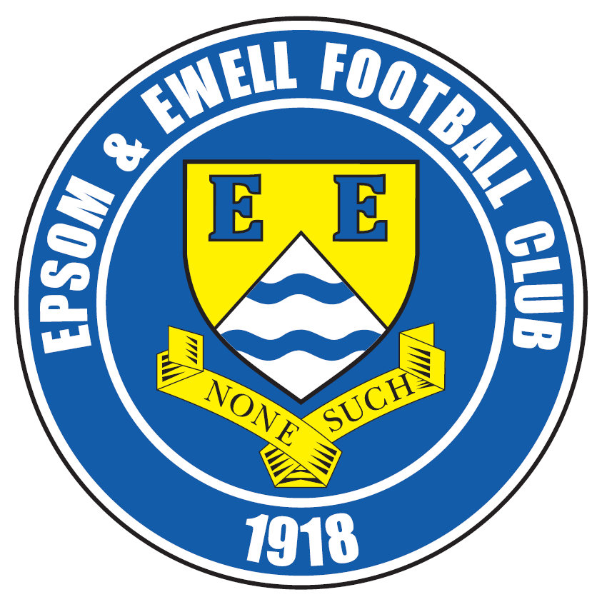 | Epsom & Ewell F.C.  19  v  Camberley Town  Tuesday, 24th February 2015
For our League Cup Quarter Final tie this evening we welcome back the players and officials of our old friends from Camberley Town along with today's match officials and of course our own regular supporters.

Our opponents will have no difficulty finding their way here as it is their third visit of the season, following trips to Chipstead for League and Surrey Senior Cup matches previously.

Much has already been said about how many times we have met Camberley in our history, yet there is no animosity of the sort that often occurs with teams that meet frequently. Maybe it is because we are not really that local to each other, so there are few player moves between the two teams, although Robbie Burns and Joe Paris are two that I can think of in recent years, while back in the eighties there was Richard Parkin, and further back there was a left winger J.Bunce who came to Epsom briefly in 1925. Apologies for the digression. It’s very difficult to write these notes without repeating what was said a couple of weeks ago!

Anyway, our regular meetings are surely in danger right now, as they are favourites to take the League title and advance to a level they haven’t inhabited since the early eighties. We wish them well in their quest for the League title, but not for a League and Cup double!

We get another good look at the main rivals for Camberley’s title ambitions on Saturday, when we make our second visit to Molesey this year, having lost to two late goals in the Surrey Senior Cup back in January. It was two early goals that hurt us in our first League match against the Moles, so maybe if we can keep it together for the whole ninety minutes we may get something out of the fixture! We then return home for two more home League games; midweek against Hanworth Villa and then Cove. All of these are of course vulnerable to our unsettled weather at present, so please keep checking the website and twitter for up to date details.

We met Hartley Wintney on Saturday, and after a slow start we went behind after 74 minutes. The response was tremendous though and although we won 2-1 with a late Kyle Hough winner, we could have had four by the end as we really stepped up the pace.

We are urgently looking for match and player sponsors, please get in touch! Also, the Salts Super Six Predictor jackpot is now up to £282 just for getting six results right. How much larger can that prize get? Based on Saturday’s feeble efforts, maybe quite a bit higher!

Thanks for watching today. Glyn, the lads and the club value your support.

Rich

Cover photo this week by Gemma Jarman

Kyle Hough scores the winner against Hartley Wintney on Saturday
Please note that Gemma has thousands more pictures on the club website.


Cherry Red Records
Combined Counties League
Premier Division Table 2014/15
inc Saturday  21st February 2015 | P | W | D | L | F | A | Pts | GD | H | A
Cove | 30 | 21 | 5 | 4 | 73 | 45 | 68 | +28 | 7/3 | 0-1
Camberley Town | 28 | 21 | 4 | 3 | 70 | 21 | 67 | +49 | 2-4 | 0-1
Ashford Town (Mx) | 28 | 19 | 2 | 7 | 69 | 34 | 59 | +35 | 2-4 | 3-1
Windsor | 30 | 18 | 4 | 8 | 71 | 40 | 58 | +31 | 0-5 | 11/4
Molesey | 25 | 19 | 0 | 6 | 76 | 25 | 57 | +51 | 1-3 | 28/2
Spelthorne Sports | 28 | 15 | 3 | 10 | 57 | 47 | 48 | +10 | 4-3 | 3-0
Hartley Wintney | 29 | 13 | 4 | 12 | 40 | 51 | 43 | -9 | 2-1 | 1-2
Badshot Lea | 27 | 12 | 5 | 10 | 56 | 45 | 41 | +11 | 21/3 | 2-4
Farnham Town | 28 | 12 | 5 | 11 | 64 | 64 | 41 | 0 | 2-4 | 2-0
Bedfont Sports | 28 | 12 | 3 | 13 | 44 | 49 | 39 | -5 | 0-1 | 2-0
Colliers Wood United | 29 | 11 | 3 | 15 | 51 | 53 | 36 | -2 | 4/4 | 2-3
Epsom & Ewell | 27 | 11 | 2 | 14 | 50 | 52 | 35 | -2 | - | -
Mole Valley SCR | 28 | 10 | 5 | 13 | 50 | 69 | 35 | -19 | 1-0 | 5-2
Chertsey Town | 30 | 10 | 4 | 16 | 49 | 66 | 34 | -17 | 1-2 | 14/3
Raynes Park Vale | 25 | 8 | 5 | 12 | 34 | 44 | 29 | -10 | 0-1 | 10/3
Knaphill | 28 | 8 | 5 | 15 | 36 | 62 | 29 | -26 | 18/4 | 4-1
Westfield | 25 | 7 | 5 | 13 | 37 | 49 | 26 | -12 | 24/3 | 0-4
Horley Town | 27 | 6 | 6 | 15 | 50 | 73 | 24 | -23 | 2-2 | 6/4
Guildford City | 26 | 6 | 3 | 17 | 44 | 76 | 21 | -32 | 4-1 | 28/3
Hanworth Villa | 26 | 5 | 5 | 16 | 35 | 56 | 20 | -21 | 3/3 | 5-2
Frimley Green | 28 | 5 | 4 | 19 | 44 | 79 | 19 | -35 | 0-0 | 25/4

Lucky Day? – 24th February
Played 11 - Won 4 Drawn 2 Lost 5 - F 14 A 21 - PPG 1.27 - Below Average
Club record against Camberley Town
Played 85 - Won 38 Drawn 20 Lost 26 Abandoned 1
F 153 A 115 - PPG 1.58 - Above Average
Last visit
Saturday 7th February 2015 - Lost 2-4 - Combined Counties League

Results and Fixtures
Combined Counties League – Saturday 21st February
Bedfont Sports | 0-1 | Cove
Chertsey Town | 4-2 | Hanworth Villa
Epsom & Ewell | 2-1 | Hartley Wintney
Frimley Green | 0-3 | Camberley Town
Windsor | 2-1 | Knaphill
Combined Counties League Cup QF – Tuesday 24th February
Epsom & Ewell | V | Camberley Town
Combined Counties League – Tuesday 24th February
Farnham Town | V | Ashford Town (Mx)
Hartley Wintney | V | Guildford City
Knaphill | V | Frimley Green
Raynes Park Vale | V | Molesey
Westfield | V | Bedfont Sports
Combined Counties League Cup QF – Wednesday 25th February
Colliers Wood United | V | Badshot Lea
Combined Counties League – Saturday 28th February
Ashford Town (Mx) | V | Horley Town
Badshot Lea | V | Chertsey Town
Bedfont Sports | V | Spelthorne Sports
Camberley Town | V | Westfield
Cove | V | Knaphill
Farnham Town | V | Colliers Wood United
Frimley Green | V | Windsor
Hanworth Villa | V | Hartley Wintney
Molesey | V | Epsom & Ewell
Raynes Park Vale | V | Guildford City
Combined Counties League Cup QF – Tuesday 3rd March
Farnham Town | V | Cove
Combined Counties League – Tuesday 3rd March
Badshot Lea | V | Horley Town
Epsom & Ewell | V | Hanworth Villa
Mole Valley SCR | V | Camberley Town
Molesey | V | Chertsey Town
Spelthorne Sports | V | Hartley Wintney
Westfield | V | Colliers Wood United

From behind the goal
Epsom & Ewell 2-1 Hartley Wintney
Combined Counties League - Saturday 21st February 2015

Salts snatch points in late, late show

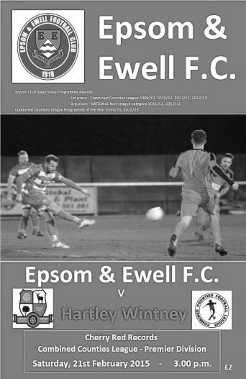
The spectators who braved the elements and witnessed an extremely dull first half were rewarded for sticking with it, as the game finally sprung into life in the last twenty minutes as for the second season in a row our boys defeated Hartley Wintney from a trailing position.

Glyn Mandeville had the luxury of a proper selection dilemma for the first time in ages and into the side came both Dan Dean and Sam Robinson after completing their suspensions, while it was also good to see the Sam Currie returning to the starting eleven since suffering a nasty knee injury back in August. However, he did not displace James Taylor at right back, instead pairing up with Matt Farrell in front of the back four. Alex McKay was away and missed out on his 100th appearance but we had a strong supporting cast, including Daryl Cooper-Smith and Kyle Hough and both would have their part to play in proceedings as the game wore on.

As is often the case after a bit of a break, you get the old conundrum; are the players fresh after having some time off, or are they rusty because they haven't played a match for a while? The answer in this game was definitely the latter as we struggled to come up with any fluency in the first half. Only Matt Ferdinando had any sort of a chance from a deep Matt Robinson cross that he met at the back post after 34 minutes but he made a hash of the header and was well off target. He had another chance five minutes later and connected well with a dropping ball to force the save out of Craig Atkinson the visiting keeper. A defender then made an equally solid connection on him and it was a surprise to see a penalty not awarded.

The visitors were not much better than us, although they did have the better of the half-chances that came and probably should have taken the lead in first half injury time but the striker pulled his shot wide from a central position.

After that scare the players came out for the second half with a bit more intensity and we began to create a bit more. Unfortunately for Robbie Burns he wouldn't get the chance to take advantage of the increased possession as he limped off early in the period, being replaced by Kyle Hough; not a bad option to have on the bench though!

Hough had been troubled by a slight injury but it didn't show any signs of hampering him as Physio Ken Jones worked his magic and he got an early run down the right wing

with his cross being set up for Sam Robinson by his brother Matt but the shot was off target. He was then challenged clumsily in the box but the appeals were waved away. It was the sort of challenge that would get awarded in the middle of the park but not normally in the penalty area.

Hough was giving the opposition defence kittens. He beat the offside trap and rounded Atkinson who recovered to make a good block from the shot from an angle after 64 minutes. However, slightly against the run of play we went behind in the 74th minute and it was a disappointing one to concede as a deep long ball from their right side of midfield dropped over our defence. To his credit Sam Argent controlled the ball instantly and with just Michael Eacott to beat he gave him no chance with a clinical finish.

This was harsh on our boys although we had been second best at the half and couldn't really have complained if we had been trailing at that stage, so we just had to raise it a gear. Actually we raised it quite a few gears from this point. On 80 minutes Daryl Cooper-Smith came on to partner Hough up front and the visiting defence, surely one of the smallest in the League, came under severe pressure. Almost straight away their keeper and a defender went for the same ball only to succeed in knocking it straight to Cooper-Smith but his volley was wide of the far post.

In the 83rd minute we were level. Cooper-Smith was found in space on the right wing and his low cross was bundled home by Hough just ahead of a defender at the near post. It was the least we deserved and Hough nearly scored again two minutes later when he was through one on one but Atkinson saved his shot with his feet. We were rampant now and Ferdinando made a twisting, turning run but his pass to our third substitute on the day Alex McGregor was a bit close to him and he could only shovel his shot straight at the keeper. However, just as the game ticked into injury time a great through ball from Sam Robinson put Hough through and he calmly finished off from close range, curling the ball low just inside Atkinson's near post to clinch all three points for the Salts.

There are positives and negatives to take out of this performance. We did take a substantial amount of time before we really got going in this match, but we showed great character to fight back and we looked really good in the final quarter of an hour. As many of our players have missed playing time recently I feel we will continue to improve still further as the season continues. We'll need to, with the three best sides in the Division coming up in the next four games. This season though, both ourselves and Hartley showed that while we can probably compete with the top sides in any given match, over the course of the season we are both in that next group of clubs that sit just behind them.

Team: Michael Eacott, James Taylor, Steve Rowe, Anthony Panayi, Dan Dean, Sam Currie ©, Matt Robinson, Matt Farrell, Robbie Burns, Sam Robinson, Matt Ferdinando

Subs: Kyle Hough for Burns (51), Daryl Cooper-Smith for Rowe (80), Alex McGregor for M.Robinson (83)

Club Records - 24th February
Date | Day | Competition |  | Opponents |  | Scorers
24/02/34 | Sat | London League | H | Leavesden | 1-5 | W.Challis
24/02/51 | Sat | Corinthian League | A | Maidenhead United | 2-4 | B.Musto, E.Watkins
24/02/62 | Sat | Corinthian League | H | Chesham United | 0-1
24/02/68 | Sat | Athenian League 2 | A | Herne Bay | 2-1 | J.Eales, J.McNaught
24/02/73 | Sat | Athenian League 2 | A | Addlestone | 0-3
24/02/79 | Sat | Isthmian League 1 | H | Maidenhead United | 1-0 | G.Archer
24/02/86 | Mon | Isthmian League Premier | A | Bognor Regis Town | 1-1 | R.Lewis
24/02/90 | Sat | Isthmian League 2s | H | Flackwell Heath | 2-2 | N.Robson, C.Hadingham
24/02/98 | Tue | Isthmian League 3 | H | Corinthian Casuals | 0-1
24/02/01 | Sat | Isthmian League 3 | A | Hertford Town | 3-2 | M.Freeborough, B.Forey, R.Sell
24/02/09 | Tue | Surrey Senior Cup Quarter Final | H | Corinthian Casuals | 2-1+ | D.Marvell (2)
Historical Decades
90 years ago – Epsom Town
21/02/25 | Sat | Surrey Senior League | H | Farnham United Breweries | 0-2
80 years ago – Epsom F.C.
23/02/35 | Sat | London League | H | Finchley | 2-1 | J.Jones, G.Collins
70 years ago – War time Epsom Town
24/02/45 | Sat | Friendly | A | South East Command (Reigate) | 4-2 | C.Cairns (2), L.Dowding (2)
60 years ago – Epsom F.C.
26/02/55 | Sat | Corinthian League | A | Eastbourne | 0-3
50 years ago – Epsom & Ewell
27/02/65 | Sat | Athenian League 1 | H | Hemel Hempstead Town | 0-2
40 years ago – Epsom & Ewell
22/02/75 | Sat | Surrey Senior League  Charity Cup 2 | A | Whyteleafe | 1-0 | P.Walker
30 years ago – Epsom & Ewell
23/02/85 | Sat | Isthmian League Premier | H | Bognor Regis Town | 1-0 | M.Stratford
20 years ago – Epsom & Ewell
25/02/95 | Sat | Isthmian League 3 | A | Harlow Town | 1-0 | S.Miller
10 years ago – Epsom & Ewell
05/03/05 | Sat | Isthmian League 2 | A | Hertford Town | 5-2 | M.Owen (2), L.Purvis, L.Gay, C.Fossey

History Corner - 24th February
90 years ago this week Champions elect Farnham United Breweries visited the Horton Hospital Grounds for a Surrey Senior League match. In just our third game as a Senior club we had gone there and won 4-0 to announce ourselves on the stage, but over the season, dropped points here or there ensured that we were only to finish third, and two first half goals for the visitors saw them on their way to repeating their League and Cup double of the previous season.

70 years ago this week our war time Epsom Town team had a friendly against South East Command who were a Reigate based Army team. Les Dowding scored twice as did Cecil Cairns in our 4-2 win. Cecil was the father of Gordon Cairns, the fifties scoring legend that played for Epsom, Carshalton and Worthing,. Not a bad result really when considering that an injury to Box had left us with ten men for much of the game.

40 years ago this week Phil Walker scored the only goal as we eased past Whyteleafe to make the Semi-Final of the League Charity Cup. Two months later we would visit Church Road again to record a club record away win of 9-0!

29 years ago today was it on, or was it off? We were scheduled to travel to Bognor Regis Town for a League match. However, in those pre-twitter and internet days the game was advised that afternoon on Teletext as being off. Then we heard that the game was in fact on and a quick run to the South coast proved worthwhile as Robin Lewis secured a rare away point that season from a 1-1 draw.

20 years ago this week Stuart Miller scored the only goal to record only our second ever win at Harlow Town’s open bowl-like Sportcentre ground. Like so many others the ground is now housing and the Hawks are now pioneering the use of a 3g pitch for their matches.

10 years ago this week we handed league leaders Hertford Town their first home league defeat of the season with a convincing 5-2 score line. The hosts weren’t helped by an early sending off for a professional foul as Chad Heuston was stopped from breaking through by a deliberate handball and we led by three goals at the half. Hertford pulled one back but we replied strongly and led 5-1 before Hertford scored a second in stoppage time.

5 years ago today Dale Marvell scored twice to defeat the Isthmian side Corinthian Casuals in the Surrey Senior Cup Quarter Final. Following our stunning win at Sutton United earlier in the season Redhill had been beaten and a home tie was seen as winnable. However, we trailed at the half until the equaliser which forced extra time but with penalties looming, Marvell cut in from the right and curled a shot with the outside of his right foot low into the far corner in the 120th minute.

First Eleven Appearances - (max 35 inc Hartley Wintney)
Name | Debut | 2014/15 |  |  |  | Career Totals
Name | Debut | App | Sub | Total | Goals | App | Sub | Total | Goals
BROWN Oshane* | 30/08/2014 | 2 | 0 | 2 | 0 | 2 | 0 | 2 | 0
BURNS Robbie | 14/08/2007 | 2 | 1 | 3 | 0 | 204 | 15 | 219 | 121
COOPER-SMITH Daryl | 03/01/2015 | 4 | 2 | 6 | 2 | 4 | 2 | 6 | 2
CURRIE Sam | 04/08/2012 | 3 | 3 | 6 | 0 | 97 | 8 | 105 | 2
DEAN Dan | 02/08/2014 | 26 | 1 | 27 | 0 | 26 | 1 | 27 | 0
DEWAR Ali | 29/10/2011 | 5 | 6 | 11 | 3 | 55 | 35 | 90 | 10
DOUGLIN Karl* | 03/08/2013 | 1 | 0 | 1 | 1 | 41 | 3 | 44 | 14
DOWNS Carl* | 17/09/2011 | 4 | 1 | 5 | 0 | 94 | 13 | 107 | 2
EACOTT Michael | 02/08/2014 | 33 | 0 | 33 | 0 | 33 | 0 | 33 | 0
FARRELL Matt | 02/08/2014 | 30 | 3 | 33 | 3 | 30 | 3 | 33 | 3
FERDINANDO Matt | 20/09/2014 | 18 | 3 | 21 | 6 | 18 | 3 | 21 | 6
GAFFNEY Luke* | 16/08/2014 | 10 | 1 | 11 | 0 | 10 | 1 | 11 | 0
HARPER Tommy* | 15/04/2014 | 1 | 0 | 1 | 0 | 2 | 1 | 3 | 0
HAYWARD Ben | 07/03/2007 | 6 | 0 | 6 | 0 | 242 | 28 | 270 | 18
HOADLEY Harry* | 27/08/2011 | 6 | 1 | 7 | 0 | 7 | 1 | 8 | 0
HOUGH Kyle | 14/08/2007 | 28 | 3 | 31 | 18 | 282 | 15 | 297 | 155
JARMAN Mark* | 08/08/2009 | 5 | 5 | 10 | 0 | 136 | 51 | 187 | 76
MARVELL Dale* | 15/01/2000 | 11 | 5 | 16 | 5 | 261 | 45 | 306 | 85
MCGREGOR Alex | 08/08/2009 | 12 | 1 | 13 | 1 | 169 | 55 | 224 | 27
MCKAY Alex | 20/12/2008 | 8 | 4 | 12 | 1 | 73 | 26 | 99 | 8
MURPHY George | 28/03/2013 | 22 | 1 | 23 | 1 | 63 | 5 | 68 | 3
MUTIMA Lionel* | 05/08/2014 | 4 | 2 | 6 | 0 | 4 | 2 | 6 | 0
NELMES Elliott* | 05/08/2014 | 2 | 0 | 2 | 0 | 2 | 0 | 2 | 0
PANAYI Anthony | 14/11/2010 | 27 | 1 | 28 | 0 | 154 | 15 | 169 | 4
PANAYIOUTOU Savva | 03/01/2015 | 5 | 0 | 5 | 1 | 5 | 0 | 5 | 1
ROBINSON Matt | 01/12/2012 | 17 | 1 | 18 | 3 | 18 | 4 | 22 | 4
ROBINSON Sam | 22/10/2011 | 19 | 1 | 20 | 6 | 43 | 4 | 47 | 11
ROWE Steve | 27/08/2011 | 9 | 0 | 9 | 0 | 14 | 1 | 15 | 0
SHAW Ollie | 20/09/2014 | 0 | 10 | 10 | 0 | 0 | 10 | 10 | 0
SMITH Matt | 08/08/2009 | 0 | 1 | 1 | 0 | 91 | 43 | 134 | 10
SMITH Taylor* | 02/08/2014 | 13 | 2 | 15 | 7 | 13 | 2 | 15 | 7
TANTON Matt | 02/08/2014 | 18 | 4 | 22 | 1 | 18 | 4 | 22 | 1
TAYLOR James | 26/08/2013 | 28 | 1 | 29 | 2 | 45 | 7 | 52 | 3
VAN GELDER Julian* | 12/09/2006 | 0 | 1 | 1 | 0 | 0 | 2 | 2 | 0
WHITE Sean* | 02/08/2014 | 6 | 13 | 19 | 3 | 6 | 13 | 19 | 3
Own Goal |  |  |  |  | 1
* Player has left the club

CCL Premier Division Club Directory
ASHFORD TOWN (Mx) Telephone: 01784-245908 - Ground: The Robert Parker Stadium, Short Lane, Stanwell. TW19 7BH - Colours: Tangerine & White Stripes/Black/Tangerine

BADSHOT LEA Telephone: 01252-320385 - Ground: Ash United FC, Shawfield Stadium, Youngs Drive, Shawfields Road, Ash, Hampshire. GU12 6RE - Colours: Claret/White/Claret

BEDFONT SPORTS Telephone: 0208-831-9067 - Ground: Bedfont Sports Club, Hatton Road, Bedfont, Middx TW14 8JA - Colours: Red & Black Hoops/Black/Red & Black Hoops

CAMBERLEY TOWN Telephone: 01276-65392 - Ground: Krooner Park, Wilton Road, Camberley, Surrey. GU15 2QW - Colours: Red & White Stripes/Blue/Red

CHERTSEY TOWN Telephone: 01932-561774 - Ground: Alwyns Lane, Chertsey, Surrey. KT16 9DW - Colours: Royal Blue & White Stripes/Royal Blue/Royal Blue

COLLIERS WOOD UNITED Telephone: 0208-942 8062 - Ground: Wibbandune Sports Ground, Lincoln Green, Opposite 199-213, Robin Hood Way, Wimbledon. SW20 0AA - Colours: Blue & Black Stripes/Black/Black

COVE Telephone: 01252-543615 - Ground: Oak Farm Fields, 7 Squirrel Lane, Cove, Farnborough, Hampshire. GU14 8PB - Colours: Yellow/Black/Yellow

EPSOM & EWELL Telephone: 01737-553250 - Ground: Chipstead FC, High Road, Chipstead, Surrey. CR5 3SF - Colours: Royal Blue & White Hoops/Royal Blue/Royal Blue & White Hoops

FARNHAM TOWN Telephone: 01252-715305 Ground: Memorial Ground, Babbs Mead, West Street, Farnham, Surrey. GU9 7DY Colours: - Claret & Sky Blue /White/ Claret & Sky Blue

FRIMLEY GREEN Telephone: 01252-835089 - Ground: Frimley Green Recreation Ground, Frimley Green Road, Frimley Green, Camberley, Surrey. GU16 6JY - Colours: Blue & White/Blue/Blue

GUILDFORD CITY Telephone: 01483-443322 - Ground: The Spectrum, Parkway, Guildford, Surrey. GU1 1UP - Colours: Red & White Stripes/Black/Black

HANWORTH VILLA Telephone: 0208-831-9391 - Ground: Rectory Meadows, Park Road, off Hounslow Road, Hanworth, Middlesex. TW13 6PN - Colours: Red & White Stripes/Black/Black

HARTLEY WINTNEY Telephone: 01252-843586 - Ground: Memorial Playing Fields, Green Lane, Hartley Wintney, Hants RG27 8DL - Colours: Orange & Black/ Orange /Orange

HORLEY TOWN Telephone: 01293-822000 - Ground: The New Defence, Anderson Way, Court Lodge Road, Horley, Surrey. RH6 8SP - Colours: Claret & Sky Blue/Claret/Claret

KNAPHILL Telephone: 01483-475150 - Ground: Brookwood Country Park, Redding Way, Lower Guildford Road, Knaphill, Surrey. GU21 2AY - Colours: Red/Black/Red

MOLE VALLEY SCR Telephone: 01932-866386 - Ground: Cobham FC, Leg O’Mutton Field, Anvil Lane, Downside Bridge Road, Cobham, Surrey KT11 1AA - Colours: Yellow/Black/Black

MOLESEY Telephone: 0208-979-4283 - Ground: 412 Walton Road, West Molesey, Surrey KT8 2JG - Colours: White/Black/Black

RAYNES PARK VALE Telephone: 020-8540-8843 - Ground: Prince Georges Playing Field, Grand Drive, Raynes Park, London. SW20 9NB - Colours: Blue/Blue/Red

SPELTHORNE SPORTS Telephone: 01932-961055 - Ground: Spelthorne Sports Club, 296 Staines Road, Ashford Common, Ashford, Middx. TW15 1RY - Colours: Light & Dark Blue/Dark Blue/Light Blue

WESTFIELD Telephone: 01483-771106 - Ground: Woking Park, Kingfield Road, Woking, Surrey. GU22 9BA - Colours: Yellow/Black/Black

WINDSOR Telephone: 01753-860656 - Ground: Stag Meadow, St Leonards Road, Windsor, Berks SL4 3DR - Colours: Red/Red/Red

Camberley Town - History
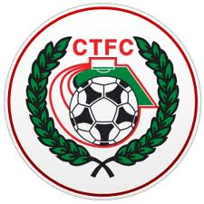
The football club was formed in 1895 at St. Michael’s Church in Yorktown and were named St. Michael’s, Camberley. They won their first trophy within two seasons beating Norwood & Selhurst 2-1 in the 1897-98 Surrey Junior Cup final. The club joined their first league, the East & West Surrey League, for the 1898-99 season and finished third.

In 1901 the club looked likely to fold and disappear due to the costs involved in running a football team but, after a public meeting, a new club named Camberley & Yorktown was formed by members of the St. Michael's committee thus maintaining a footballing presence in the area. Camberley & Yorktown took the place of St. Michael's in the East & West Surrey League before joining the Aldershot Combination in 1902 followed by the Ascot & District League in 1903 where the club won four titles and finished second three times in the seven years they spent in the league. The club went on to appear in three more Surrey Junior Cup finals, the first of which came in 1908 when Camberley & Yorktown took on Kingston at Woking and were beaten 2-0. The following season also resulted in a defeat in the final this time losing 1-0 to Selhurst Park. The1909-10 season saw victory at last as Camberley & Yorktown defeated Sutton United 2-1 at Kingston.

The club moved to the West Surrey League in 1910 and in 1913 made their first appearances in both the F.A. Cup and F.A. Amateur Cup. On September 13th 1913 Camberley & Yorktown played host to Sutton United and won 5-3 in their first F.A. Cup match. The first F.A. Amateur Cup game was disappointing though as Camberley & Yorktown were soundly beaten 7-0 by the Royal Army Medical Corps. However, the club went on to win the league title that season.

After World War I Camberley & Yorktown decided to concentrate their efforts on the Aldershot Senior League until 1922 when the club submitted an application to join the Surrey Senior League. This was accepted so Camberley & Yorktown became founder members of the league and remained in it for over 50 years. The club moved into their present ground at Krooner Park in 1923. The ground had been paid for from the winnings of a racehorse named 'Krooner' at Haydock Park in 1920. The 1930’s saw unequalled success at the club as they won the Surrey Senior League title three seasons running between 1930-31 and 1932-33 and appeared in the final of the Surrey Senior Cup in 1936 where they were beaten 3-1 by Wimbledon at Champion Hill, Dulwich.

After World War II Camberley & Yorktown dropped the 'Yorktown' part of their name as what had been two separate places when the name was first chosen had since merged to become one town. Krooner Park was not ready for use by the time the league resumed after the war so the club started the season at the London Road Recreation Ground which had been one of the grounds used before the move to Krooner Park. Success was hard to obtain with only a victory in the Surrey Senior Charity Cup in 1952 against Chertsey and a further appearance in the final of the same competition three seasons later to show for their efforts in the fifties and sixties.

In 1967 discussions took place between the two senior teams in the town, Camberley Wanderers and Camberley F.C. The two clubs decided that it made sense to merge and on 2nd June 1967 became Camberley Town F.C. The first decent season as Camberley Town came in 1972-73 when third place was achieved in the league and there was an appearance in the League Charity Cup final. They lost 3-2 to Westfield in the final at Weybridge. In their bid to bring a higher grade of football to the town the club joined the Spartan League in 1973 and installed floodlights in 1974. The official opening of the floodlights saw what is believed to be a record home attendance of around 3,500 people watch Camberley draw 1-1 with Malcolm Allison's Crystal Palace team.

In 1975 Camberley joined the Athenian League followed by the Isthmian League in 1977. Promotion to Division One of the Isthmian League was achieved in 1979 along with victory in the final of the Surrey Senior Cup where Leatherhead were beaten 4-1 after extra time at Imber Court. However, collapse soon followed and within three seasons Camberley found themselves back in the Athenian League and struggling on and off the pitch. Expansion of the Isthmian League in 1985 gave Camberley a route back into the league which was happily accepted.

In 1986 the Club enjoyed their best run in the F.A. Vase reaching the quarter finals where they went out to eventual winners Halesowen Town. The Aldershot Senior Cup was won in 1997 and 1998. 1997-98 also saw Camberley reach the Fourth Qualifying Round of the F.A. Cup equalling their best performance since the 1930's. In the league they missed out on promotion on the final day of the season. In 1998-99 Camberley went one better in the F.A. Cup reaching the First Round Proper for the first time where they were knocked out by Division 3 side Brentford.

With the disbanding of the Isthmian League second division in 2006 Camberley were placed in the Combined Counties League for the 2006-07 season and have since secured their best run of league placings for many years as well as winning the League Cup in 2009 beating Worcester Park in the final at Carshalton Athletic F.C.

Current first team manager Dan Turkington took the helm during 2012-13 season. The club finished in second place in the league in 2014 which was their highest finish in any division since 1979. They also got to the final of the Aldershot Senior Cup but lost 4-3 to Alresford Town at Aldershot Town F.C.

The club's official website is www.camberleytownfc.co.uk and there's an active Twitter account at:
https://twitter.com/CamberleyTownFC

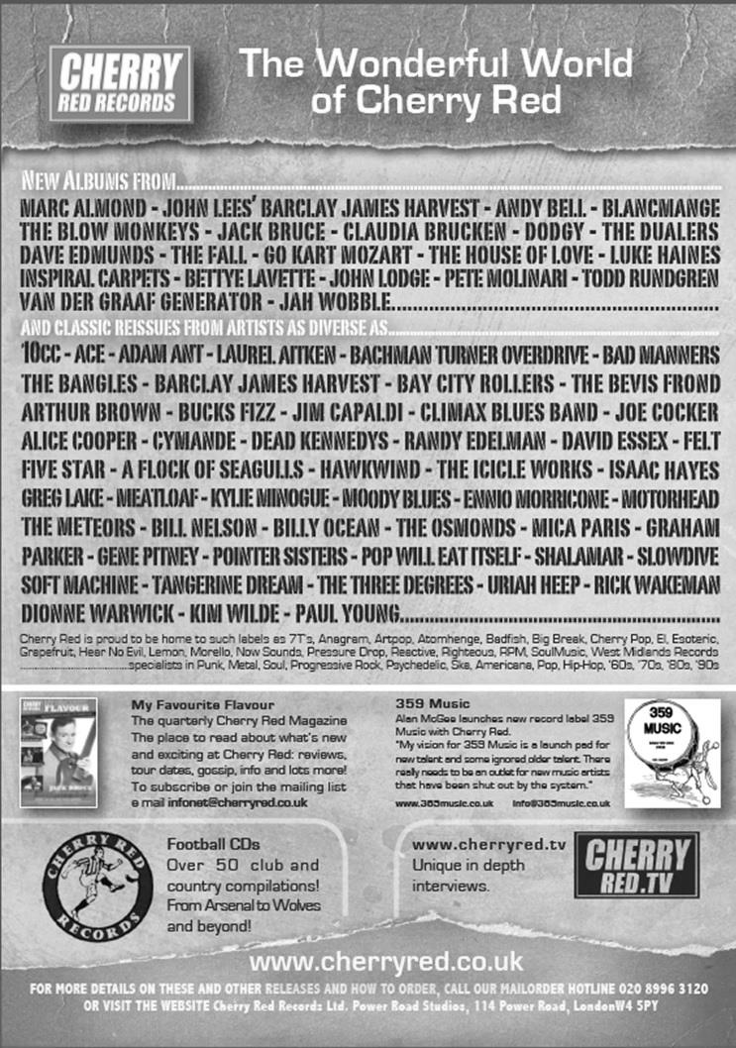
Centre page for results

Centre page for results



EL Records Premier Challenge Cup
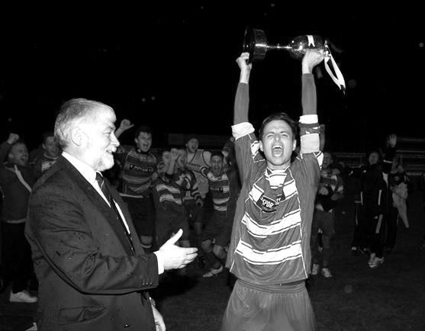
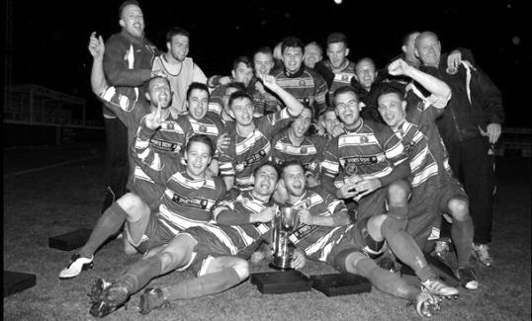
Second Round
Alton Town | 1-4 | Farnham Town
Ashford Town (Mx) | 5-0 | CB Hounslow United
Badshot Lea | 10-2 | Dorking
Bedfont Sports | 1-1+ | Cove
Cove won 4-1 on penalties
Camberley Town | 0-0+ | Molesey
Camberley Town won 3-0 on penalties
Chertsey Town | 0-7 | Windsor
Cobham | w/o Horley | Horley Town
Colliers Wood United | 3-0 | Bedfont & Feltham
Epsom & Ewell | 2-1 | Knaphill
Epsom Athletic | 0-5 | Banstead Athletic
Eversley & California | 2-4 | Ash United
Frimley Green | 1-0+ | Spelthorne Sports
Hanworth Villa | 2-3 | Guildford City
Sheerwater | 1-6 | Mole Valley SCR
Westfield | 4-0 | Farleigh Rovers
Worcester Park | 1-0 | Chessington & Hook United
Third Round
Westfield | 2-3+ | Cove
Badshot Lea | 5-0 | Guildford City
Worcester Park | 6-1 | Banstead Athletic
Farnham Town | 2-0 | Mole Valley SCR
Frimley Green | 0-5 | Epsom & Ewell
Windsor | 8-1 | Ash United
Colliers Wood United | 3-2 | Horley Town
Camberley Town | 3-0 | Ashford Town (Mx)
Quarter Finals
Colliers Wood United | 25/2 | Badshot Lea
Worcester Park | 21/3 | Windsor
Epsom & Ewell | 24/2 | Camberley Town
Farnham Town | 3/3 | Cove

Player Sponsorship
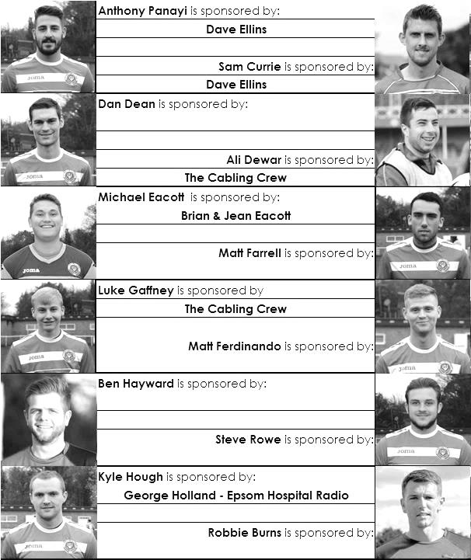

Here is the latest list showing all of the players and Management available for sponsorship. Sponsorship costs just £40 so if you want to help the club, the player and get your name in the programme for the season, let us know before they go!

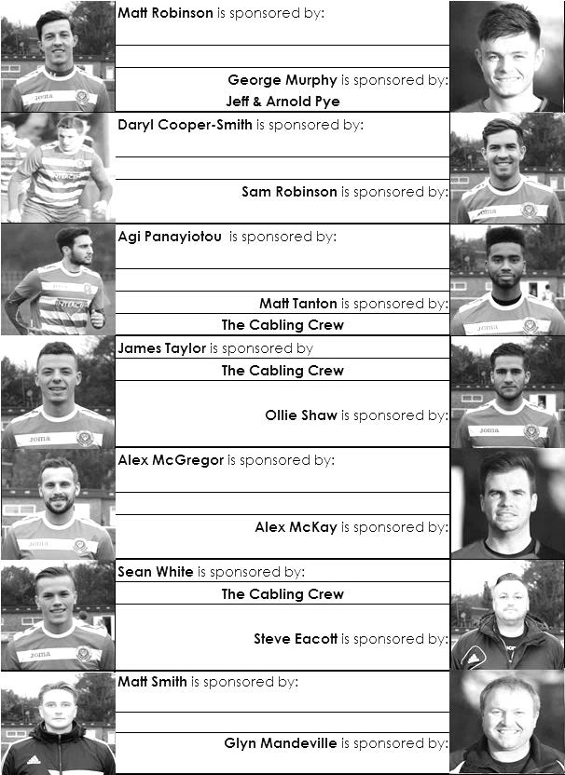

Every Opponent A-Z
Over the years we have played many, many different opponents. Exactly how many is a difficult question, as it all depends on your definition. Are Camberley & Yorktown different to Camberley Town, or are Epsom Town different to Epsom F.C. or Epsom & Ewell F.C.?

In my analysis I have classed them as the same team, and will work through them all from A to Z. Some we have played many times, whilst others we have met maybe just once or twice. Enjoy!


Mitcham Wanderers: Played 19 - W8 D3 L8 - F30 A30 - PPG - 1.42 - Average

We take a trip back to the early days this week to focus on one of our first real rivals.

Before the existence of Tooting & Mitcham United there were two teams; Tooting Town and Mitcham Wanderers. Both were in the London League when we joined the ranks in 1927. Although we played Tooting frequently at their ground in Sandy Lane that would be used by the merged club from 1932, Mitcham were arguably our closest rivals, as we often had big battles, while our record against both Tooting Town and our other close rivals at the time, Carshalton Athletic was much better and so maybe we didn’t see them as so much of a threat.

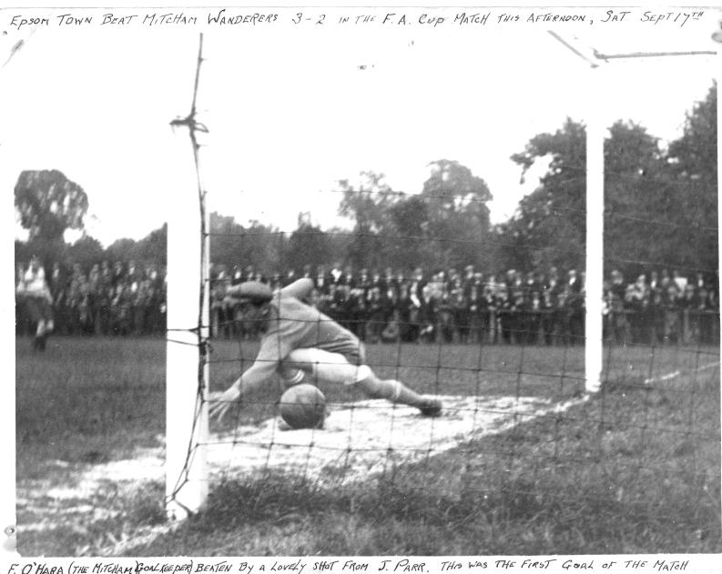
We first met the Wanderers on 17th September 1927 in an F.A. Cup tie at West Street, winning a close game in front of 1,600 spectators by three goals to two, requiring a late Reg Marlow winner after we had led a two goal lead slip. The picture below shows Jack Parr scoring the first of his two goals in the match after just five minutes.

Of course regular readers will know that 1927/28 was the year that we won the London League and we had two meetings that season. Goals from Reg Marlow and Wilfred “Bronk” Challis secured a 2-1 home win on 21st January 1928 and around 2,000 were present for our first ever visit to Streatham Road on 14th April 1928, when R.Wilcox and Reg Marlow scored our goals in a 2-0 win.

The following season Mitcham Wanderers would take the League title and again meeting twice towards the end of the season, they triumphed 1-0 at West Street in March and then 4-0 on the final day of the season, 4th May, to clinch the title at Streatham Road.

We met four times in 1929/30; twice in the League, losing both games by the odd goal, although we shared the Cup results, losing 1-2 at Streatham Road in the Surrey Charity Shield, but winning 1-0 at West Street in the F.A. Cup (see programmes right).

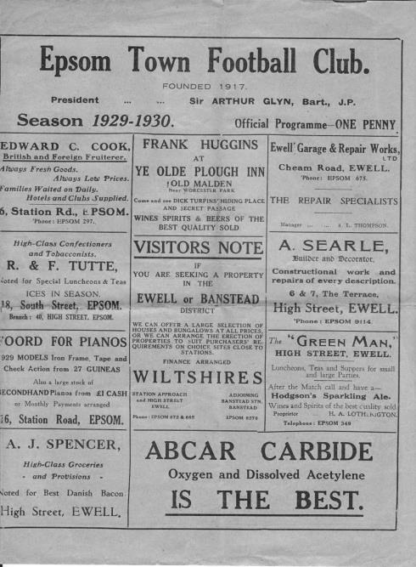
The 1930/31 season was bizarre. You might think that we play Camberley frequently, but we actually met Mitcham Wanderers on seven occasions, with two other scheduled minor cup ties being postponed! We met in the Wilson Hospital Cup, drawing 0-0 but no replay was ever held. It was just as well as we played twice in the League, losing at home but winning away, while they knocked us out of both the Surrey Senior Cup and the F.A. Cup.

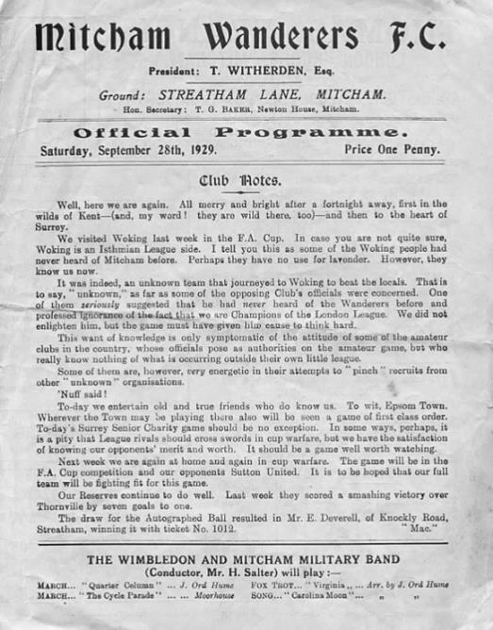
However, the biggest meeting that season was in the Amateur Cup. Over 2,500 were gathered at Mitcham for the tie which was by October, already our third visit there! A hugely entertaining match, described as “one of the hardest, closest and most exciting games” by the Epsom Advertiser ended after 120 minutes of action as a 1-1 draw. The main battle was between their centre forward Jackie Pullen and our keeper Jack Forster. Despite Forster being an amateur boxer, he will have faced very few challengers of Pullen’s stature and although Fred Behn put us ahead just before half time with a 25 yard strike, the big news was a collision between the two combatants which ended with both of them and the ball in the net! Although such challenges were legal in those days, the referee disallowed the goal, although inexplicably blew to award a penalty within seconds of the resumption of play from which they equalised.

The replay was equally hotly contested. With both sets of supporters already stoked up by the previous week’s exertions, home advantage proved crucial as Epsom scored three times in the second half to win 5-1. Soon after the fifth goal, their keeper A.G. Shoesmith reacted to taunts from the crowd and left the pitch to assault an Epsom supporter!

We met twice more in 1931/32 before the merger with our boys winning 4-2 at home and then drawing 2-2 on what would be our final visit to Streatham Road. Housing covers the site now, as of course more recently happened to Sandy Lane. The irony of the merger meant that some players found themselves surplus to requirements but two of our most hated opponents then joined us; the aforementioned Pullen, and centre half Dick “Tug” Wilson. Both would stay for years, with Pullen scoring over a hundred goals for us and Wilson playing five consecutive seasons without missing a match to set a club record that stands today. He even married the sister of one of our regular supporters Wilf Smith!

Surrey Senior Cup
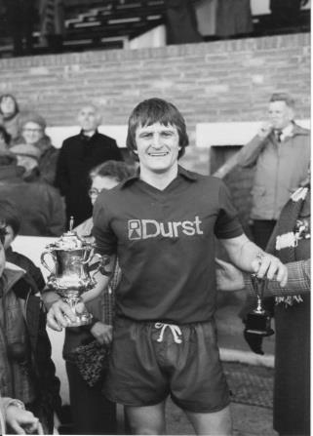
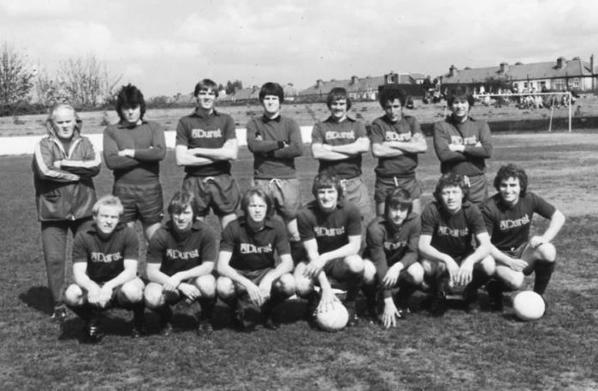
Second Round
Lingfield | 0-1 | Westfield
Redhill | 2-1 | Raynes Park Vale
Played at Raynes Park Vale
AFC Wimbledon | w/o Chipstead | Chipstead
Godalming Town | 2-4 | Mole Valley SCR
Knaphill | 0-3 | Colliers Wood United
Metropolitan Police | 1-0 | Walton & Hersham
Epsom & Ewell | 1-0 | Camberley Town
Leatherhead | 2-1 | Farnham Town
Merstham | 3-1 | Beckenham Town
Molesey | 1-0+ | Egham Town
South Park | 1-4 | Sutton United
Walton Casuals | 1-2 | Corinthian Casuals
Badshot Lea | 2-1 | Kingstonian
Dorking Wanderers | 9-0 | Frimley Green
Tooting & Mitcham United | 2-2+ | Horley Town
Tooting & Mitcham United won 4-2 on penalties
Woking | 0-3 | Ashford Town (Mx)
Third Round
Merstham | 2-1 | Sutton United
Redhill | 0-2 | Westfield
Dorking Wanderers | 3-4 | Colliers Wood United
Molesey | 3-1 | Epsom & Ewell
Leatherhead | 2-3 | Ashford Town (Mx)
Metropolitan Police | 3-0 | Chipstead
Tooting & Mitcham United | 3-1 | Mole Valley SCR
Corinthian Casuals | 1-4 | Badshot Lea
Quarter Finals
Ashford Town (Mx) | 3-1 | Westfield
Colliers Wood United | 0-2 | Merstham
Molesey | V | Badshot Lea
Met Police | 2-1 | Tooting & Mitcham United

F.A. Vase
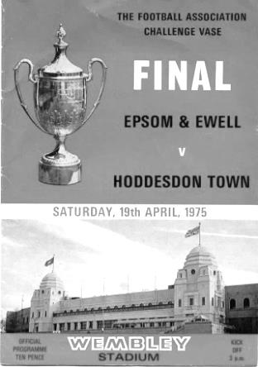
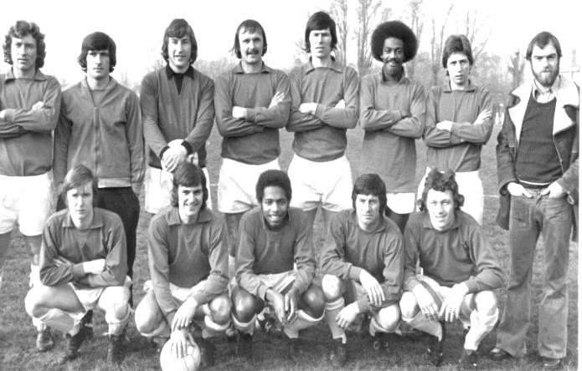
Fifth Round – 7th February
Bradford Town | 0-2 | Highworth Town
AFC St Austell | 2-0 | Stanway Rovers
Ascot United | 3-0 | Norwich United
Shaw Lane Aquaforce | 3-2 | Flackwell Heath
Glossop North End | 2-2+ | Dunston UTS
Replay – 21st February
Dunston UTS | 1-3 | Glossop North End
Holbeach United | 2-3+ | Erith & Belvedere
North Shields | 4-1 | Phoenix Sports
AFC Mansfield | 0-3 | Tadcaster Albion
Quarter Finals – 28th February
AFC St Austell | V | Ascot United
South Western Peninsula | V | Hellenic
Erith & Belvedere | V | North Shields
Southern Counties East | V | Northern
Shaw Lane Aquaforce | V | Glossop North End
Northern Counties East | V | North West Counties
Highworth Town | V | Tadcaster Albion
Hellenic | V | Northern Counties East

Match and Ball Sponsorships – 2014/15
Opponent | Date | Match Sponsor | Ball Sponsor
Raynes Park Vale | 05/08/14 | Club President - Stella Lamont
Horley Town | 25/08/14 | EEFC Management Committee
Croydon (FAC) | 30/08/14 | EEFC Media Officer - Richard Lambert
Frimley Green | 13/09/14 | Dave Gaffney and friends
Guildford City | 30/09/14 | The Jarman family
Mole Valley SCR | 07/10/14 | Mark and Carmel Murphy
Bedfont Sports | 11/10/14 | Epsom & Ewell F.C. Colts
Knaphill (LC) | 14/10/14 | Geoff and Steve Dyke
Ashford Town (Mx) | 18/10/14 | The Building Shop, Bookham
Chertsey Town | 28/10/14 | In Memory of Bob Bexley
Molesey | 22/11/14 | The Cabling Crew 0208 -224 4110
Camberley Town (SSC) | 02/12/14 | In memory of Liz and Doug Burns
Spelthorne Sports | 16/12/14 | long serving supporter Paul Merritt
Windsor | 03/01/15 | Ezara Beddoe
Farnham Town | 17/01/15 | In memory of Chris Henry
Camberley Town | 07/02/15 | Former player Marvin Hough
Hartley Wintney | 21/02/15 | Steve and Geoff Dyke
Camberley Town (LC) | 24/02/15
Hanworth Villa | 03/03/15
Cove | 07/03/15
Badshot Lea | 21/03/15
Westfield | 24/03/15
Colliers Wood United | 04/04/15 | Nathan Lambert
Knaphill | 18/04/15
For League, League Cup and Surrey Senior Cup Matches:

Match sponsorship - £40.00 Match ball sponsorship - £25.00.
Combined Offer of Match and Match Ball sponsorship for £55.00.

For F.A. Cup and F.A. Vase matches:

Match sponsorship - £50.00 Match ball sponsorship - £30.00.
Combined Offer of Match and Match Ball sponsorship for £65.00.
----------------------------------------------------------------------------------------------------------------------------
Sponsorship includes: (x2 for match, x3 for match and ball)

Admission, programmes, hospitality and advertising and mascot for the day (if required).

If you are interested, just speak to a Committee Member, you know where we are!
Alternatively, drop me an email at: richard.c.lambert@gmail.com

Salts Super Six Predictor
The Salts Super Six Predictor is live again. The next matches are TODAY and tickets are on sale at today’s game to the left of the gate.

The competition is easy to play and you don’t even have to be at the match! To win, you simply need to predict the results of six matches correctly from the three options, fill in the form and make sure it is back with one of our distributors before the deadline on the ticket. The latest fixtures are shown here.

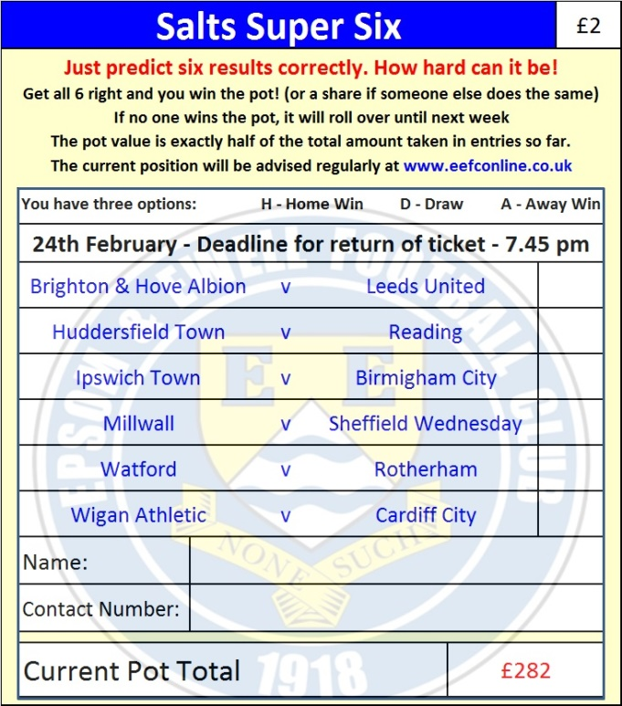
If you are a club regular, you just need to place your name on the sheet, although if you aren’t, then we’ll need a contact number from you too. We will announce any winners on the website within three working days, so don’t worry, we won’t miss you!

The prize pot is currently £282 but will continue to go up, if unclaimed, by the cost of 50% of all the sold tickets. In other words, if we sell 50 tickets at £2 before the deadline, and the pot isn’t won, then the next prize would be £332! You’ll always know the size of the pot before you enter.

Please note that if there is more than one winner, the prize pot would be shared between the winners. All you need to do now is have a go, as many times as you like!

Good luck!

Combined Counties League Cup – Quarter Final
Tuesday, 24th February 2015 - Kick-off 7.30 p.m.
Epsom and Ewell  (Royal Blue & White hoops) | V |  | Camberley Town  (Red and White Stripes)
 | NUMBERS
Michael Eacott |  |  | Craig Bradshaw
James Taylor |  |  | Matthew Humphrey
Steve Rowe |  |  | Carl Garstang
Anthony Panayi |  |  | Nick Sowden
George Murphy |  |  | Doug Ford
Dan Dean |  |  | Daniel Jewell
Matt Ferdinando |  |  | Freddie Kelsey
Matt Farrell |  |  | Matthew Bunyan
Kyle Hough |  |  | Keith Emmerson
Alex McGregor |  |  | Perry Coles
Matt Robinson |  |  | Jamie Hoppitt ©
Daryl Cooper-Smith |  |  | Dave Hill
Alex McKay |  |  | Sam Slater
Sam Robinson |  |  | Dean Greenwood
Matt Tanton |  |  | Marcus Cousins
Savva ‘Agi’ Panayiotou |  |  | Emmanuel Quarshie
Sam Currie |  |  | Dale Webb
Ali Dewar |  |  | Brad Smith
Robbie Burns |  |  | Jon Burch
Ben Hayward
Glyn Mandeville | MANAGER |  | Dan Turkington
Matt Smith | ASSISTANT
Steve Eacott / Alex McKay | COACHES |  | Dean Greenwood, Sam Rafique
Ken Jones | PHYSIO
REFEREE: A.Goodwin (Wallington)
ASSISTANTS: M.Ford (Sutton), R. Van Niekerk (Sutton)
Please note that this match could go to extra time and penalties, should they be required

OUR NEXT VISITORS TO HIGH ROAD
Hanworth Villa
Tuesday 3rd March 2015 - Kick-off 7.45 p.m.
Combined Counties League – Premier Division

